A-VIEW Client Installation Guide

(For v 4.0)

Amrita E-Learning Research Lab

Amrita e-learning research lab

A-VIEW Client Installation Guide (Importing A-VIEW Client side into Flash builder )

# Importing A-VIEW client project

This document explains the steps involved in importing A-VIEW client side code into Flash builder work space.

This document has the following software installed as prerequisites:

1. Flash Builder 4.5 or above (Or Eclipse)
2. Flex 4.6 AIR 3.4 SDK

In Flash Builder, select ***File***and choose ***Import Flash Builder Project***. (Refer Fig: 1)

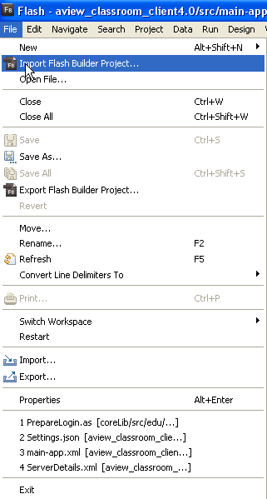

Fig: 1 – Select Import from menu

In the ***Import Flex Project wizard***, browse the project to import (Refer Fig: 2 and 3) and click ***ok*** in the ***Browse for folder wizard***.

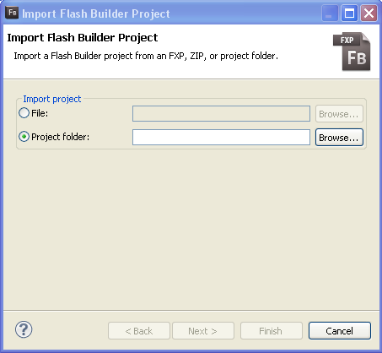

Fig: 2 –Import wizard to browse the project

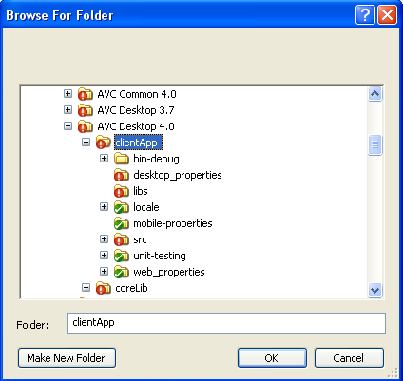

Fig: 3 – Browse project wizard

After selecting the project, click ***Finish*** button in the ***Import Flash Builder Project wizard***. (Refer Fig: 4)

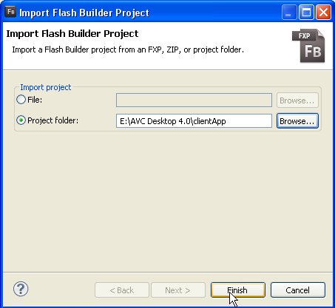

Fig: 4 – Project import wizard

Likewise import ***AviewCore*** library project also to the Flash builder. Once both projects are imported, it will look like Fig 5.

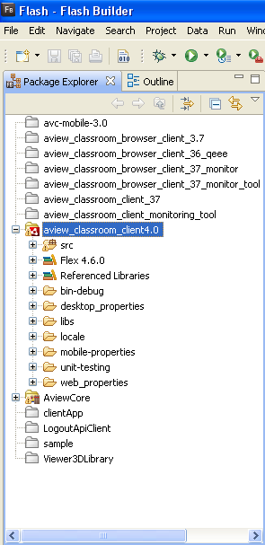

Fig: 5 – Project view

# To configure and setup SDK

After importing project you may get error. (Refer Fig: 6)

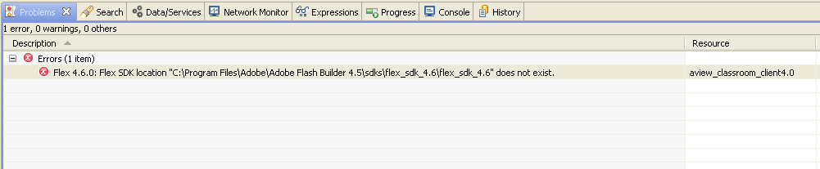

Fig: 6 – Error message because of lack of proper SDK

To solve that issue, you have to set SDK path. Copy ***AIR 4.6-3.4*** SDK to “C:\Program Files\Adobe\Adobe Flash Builder 4.5\sdks” location.

In Flash Builder, do right click on the project and select Properties, and click ***Configure Flex SDKs*** under Flex Compiler options (Refer Fig: 7).

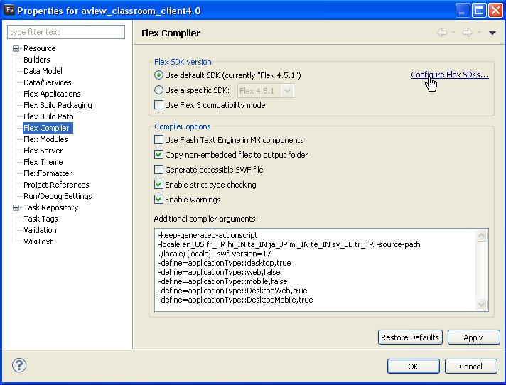

Fig: 7 – Properties of Flex Compiler

From ***Preferences (Filtered)*** wizard, click on Add Button to add flex SDK. Use ***Browse*** button to browse SDK and give a name for the new Flex SDK, say “AIR 4.6-3.4”. Then click on ***Ok***. (Refer Fig: 8)

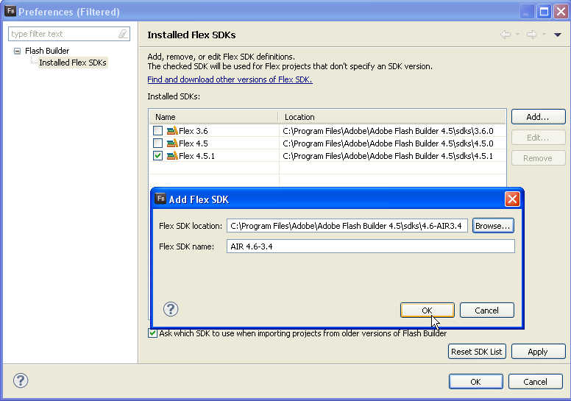

Fig: 8 – Configure SDK

Now check ***AIR 4.6-3.4 SDK*** from drop down list to make it as the default SDK and click ‘***Apply*** ‘and then ‘***Ok***’.

For each project, we can choose SDK, so here, for our project, we need the new SDK (Flex 4.6 with AIR 3.4)(Refer Fig: 9).

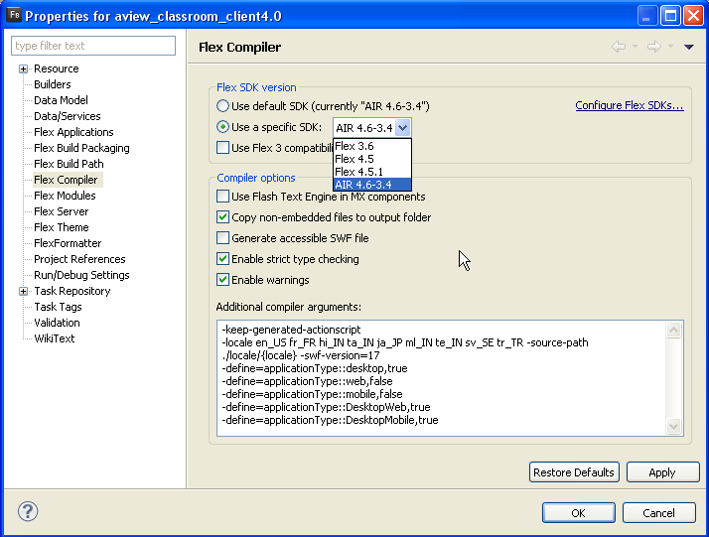

Fig: 9 – Set SDK for A-VEIW